Project Name

Students : Mohammad Farhan, Muhammad Zeidan.
Supervisor : Tuvia Liran.
Semester : Winter 2024

Project Description:
Prepare a short description of the goals of the project as you understand them. For example:

This project aims to design and build a charge pump DC to DC converter using only switches and capacitors with the primary objective of achieving the highest yield possible. Yield optimization will be a key focus throughout the design and implementation process, ensuring that the converter delivers reliable performance with minimal defects or failures. By employing efficient circuit design techniques, rigorous testing methodologies, and careful component selection, the project will strive to maximize the yield of the converter while meeting all performance requirements. Additionally, the converter will be capable of stepping down a high input voltage to a lower output voltage efficiently and reliably, making it suitable for a wide range of applications.

Project Requirements:
- Transistors and capacitors based circuit only.
- Maximum power efficiency
- Maximum area efficiency
- Spice using spectre
- Simulations using virtuoso
Project Specifications:
- Spectre on virtuoso
- Technology: Tower 0.18u CMOS
- we might need some special values for resistors and capacitors.
Development Stages / Design Flow | Tools
Ideal circuit on spice | LTspice
Practitcal circuit on spice | Spectre (spectra)
Functional simulation | Virtuoso

Literature
Provide a brief summary of the literature used for the project.
A charge pump converter is a type of DC/DC converter that uses capacitors to raise or lower voltages. These converters often take up a smaller area, have high efficiency, and are incredibly cost-effective. They are often used in the backlight of thin-film-transistor liquid-crystal displays (TFT-LCD), optical modules, and they can drive the upper transistor (N-channel MOSFET) of a buck circuit

Alternative solutions
DC-DC Buck Converters: These are commonly used in electronics projects where you need to step down voltage from a power source to match the requirements of a particular component or circuit. They are widely available in various voltage and current ratings.

Selected solution
Because These converters often take up a smaller area, have high efficiency, and are incredibly cost-effective, and are simple to implement.

Top Level Interface

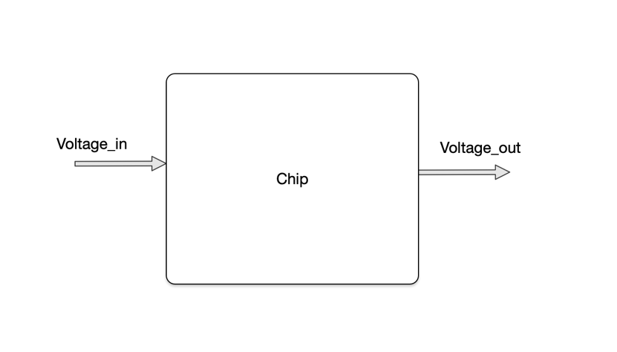

Top Level Architecture
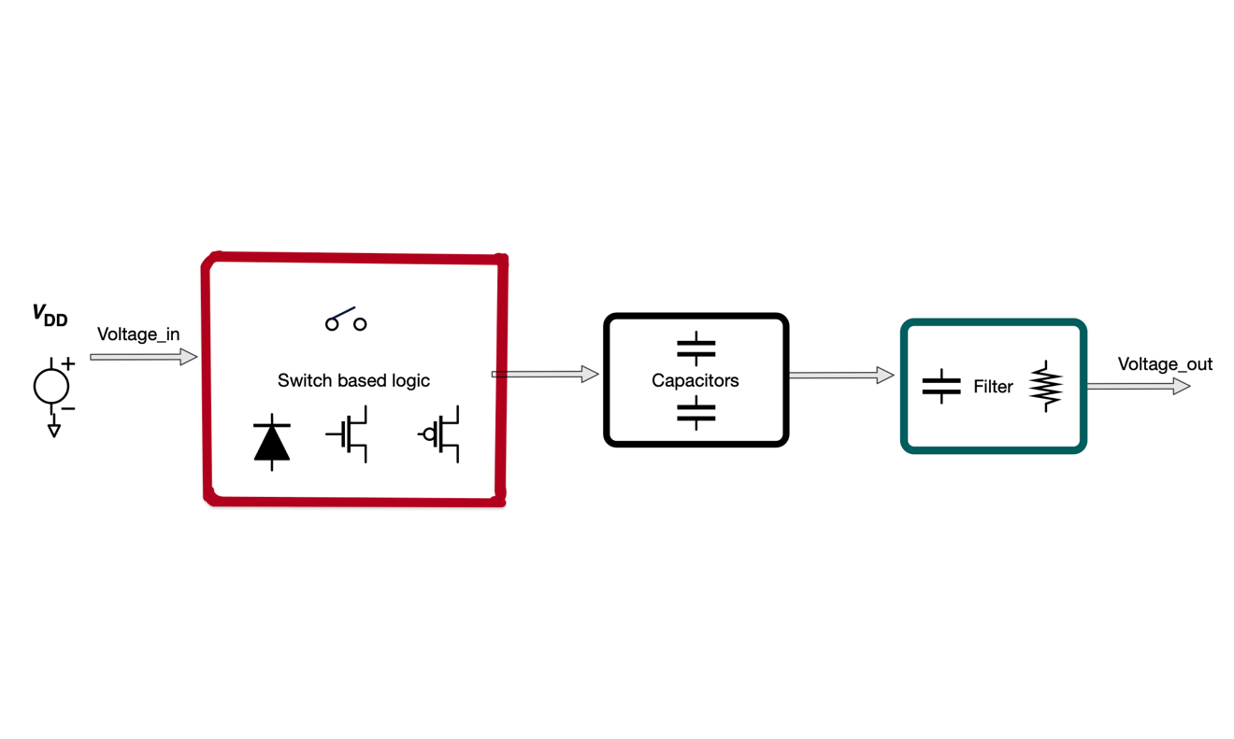
Example
Project Schedule :
Try and estimate as accurately as possible the schedule for your project. For example:

Provisional/Preliminary Schedule  Literature  Ideal circuit and logic validation  Practical circuit  Simulations  Improving the circuit  Layout Design  Report | Week  1-2  3-4  5  6  7-11  12  13

Please prepare a Gantt chart as follows: Gantt Chart Example:
Literature

Ideal circuit and logic validation

Practical circuit

Simulations

Improving the circuit

Layout Design

Report

Week 1 2 3 4 5 6 7 8 9 10 11 12 13 14 15

